TASK:
You should spend about 40 minutes on this task.
Globalization is a phenomenon characteristic of the present-day world. What are the advantages and disadvantages of globalization?
Write an essay to give your answer and include any relevant examples from your own experience or knowledge.
You should write at least 250 words. Your response will be evaluated in terms of Task Fulfillment, Organization, Vocabulary and Grammar.

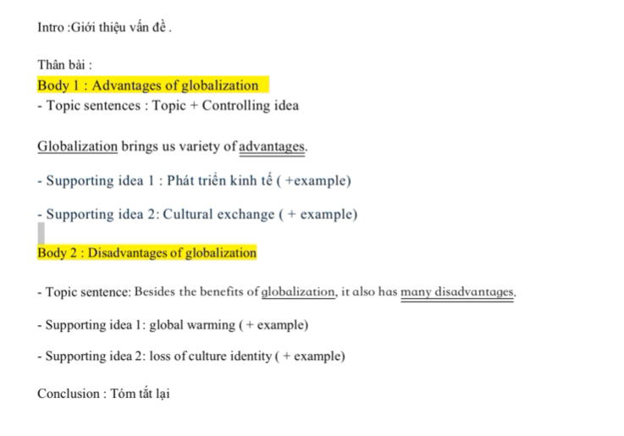
As a result of the progress in the global economy and international relationship, globalization is the present trend in every country. The truth is that globalization brings about its merits of economic growth and cultural exchange, alongside its own demerits, namely environmental pollution and identity loss.
On one hand, globalization comes with a variety of advantages. Firstly, a open economy helps a country develop rapidly through foreign investment. It allow developed countries to invest in developing ones for a cheaper labour cost, which consequently lower the products cost for everyone. Moreover, because of the exchange rate differences, foreign currencies notably help citizens improve their livelihood. An example in Vietnam is that Samsung factories in Bac Ninh province have increased the local areas average income to the top of the country. Additionally, cultural exchange has a paramount role in breaking down barriers in numerous aspects fields. In education, students can access various overseas study opportunities. In science, there are plenty of international co-operation scientific subjects that have promising results.
On the other hand, internationlization contains some significant drawbacks in which global warming is the clearest consequence. The main culprit for this negative effect is logistics. Countless transportation vehicles such as cargo ships, trains, trucks and airplanes annually discharge a huge amount of carbon dioxide. Another serious effect of cultural integration is the loss of cultural identity. Because of the growth of the internet and social networks like Facebook and Twitter, present day teenagers is prefer foreign culture to their traditional root. This pessimistic situation might lead to a future where well-preserved cultural values disappear.
In conclusion, although globalization accompanied by disadvantages of environmental pollution and cultural identity loss, the myriad of positive effects it brings about for the economy and international collaboration is also worth considering. Each country should have some appropriate measures to limit these downsides while making full use.

